|  |
| --- |
| Victorian State Accident Executive Summary |
| Danny Thai (s5230918)  Sean Karl Angelo Enarbia (s5228570) 2810ICT Software TechnologiesOctober 9, 2022 |

# Abstract

The executive summary for the finding for the summary is that the Victorian State Accident that most of the testing are to be succeed although there are four to be conducted. Due to the file being a large size, the functions in Jupyter’s Notebook cannot handled largely size and the data source cannot display the whole table rows of the csv file of the Victorian State Accident.

# Introduction

The project plan is our first step for both partner and I to start this assessment. We have specifically chosen the Victorian State Accident Data Structure. We have chosen this is because the data analysis has been recorded for the last five years showing all the accident types, time zones and types that has occurred in that time. It is our job to analysis and plan such as introduction, Work Breakdown Structure (WBS), Activity Definition and estimating our time in real-life when completing each task for the Gantt Chart.

# **Analysis 1 Project Plan**

The project plan is our first step for both partner and I to start this assessment. We have specifically chosen the Victorian State Accident Data Structure. We have chosen this is because the data analysis has been recorded for the last five years showing all the accident types, time zones and types that has occurred in that time. It is our job to analysis and plan such as introduction, Work Breakdown Structure (WBS), Activity Definition and estimating our time in real-life when completing each task for the Gantt Chart. For this part for this assessment, this could take both of us at least a week to complete this step.

# **Analysis 2 Software Coding**

After planning the project and software document, we are now to input the data structure of the Victorian State Accident and start implement the code for the file (which is csv) either in PyCharm or Jupyter’s Notebook. We decided to use panda as the main data structure source for the file to read the data source. We use the Jupyter’s Notebook to implement and show the results of the accident data structure and conduct tests so see if the coding and the search results function perfectly without error. This part of this assessment has taken us a day to complete due to implement and coding correct functions into Jupyter.

# **Analysis 3 Software Testing Report**

When we conduct the test in Jupyter’s Notebook, we have conducted four test due to one error. We are to record this into the testing report to see each test are success or fail. One out of four test seems to fail and only three has succeed. The first test is to see if the csv file can be opened with the correct functions to the notebook. When executing it, the file seems to have an error saying that “unhashable type: DataFrame” meaning that the data is a largely size and cannot display the whole rows of the tables that is provided within the Data source. The other three tests we conduct is showing the results of the specific result such as ID or only showing the rows of columns for the any types of the crashes. This tasks could takes us at least one whole week to complete due to many testing in the software and recording.

# **Analysis 4 Work Breakdown Structure**

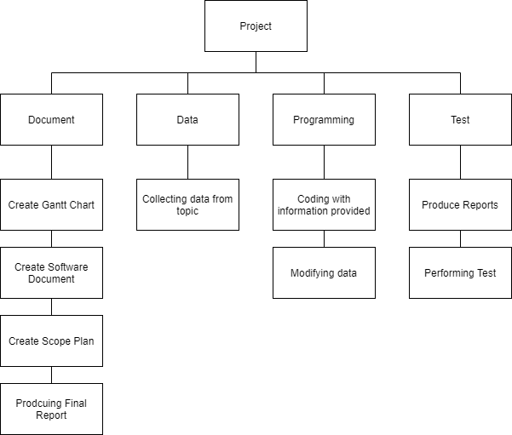

# **Analysis 5 Software Testing Images**

Testing One

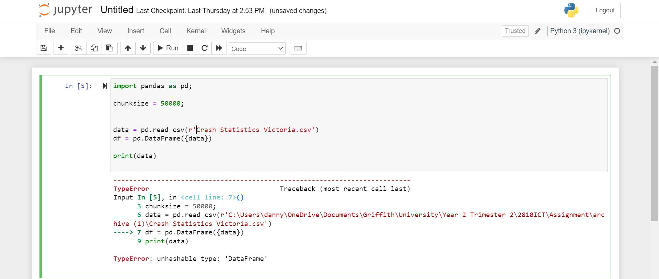

Test Two

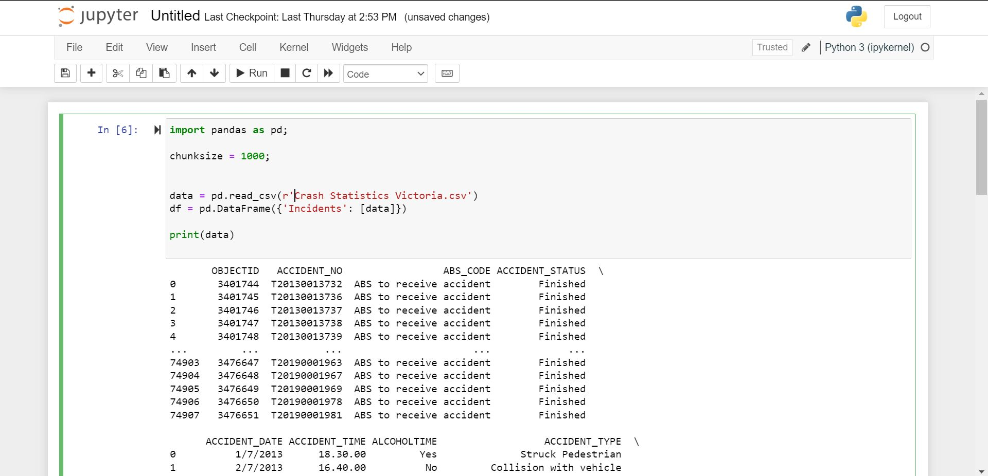

Test Three

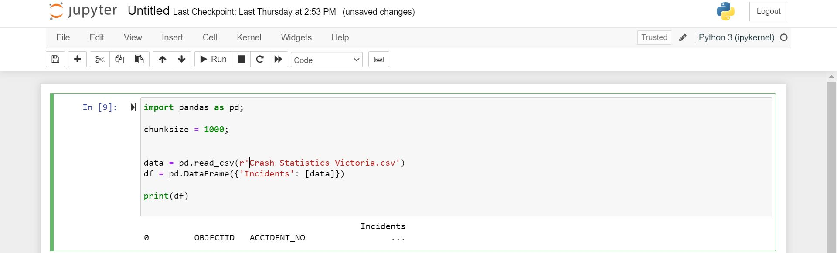

Test Four

# 